BGCCC 2021 Events Status

RD meeting 5/12/21

1:30-3pm

Attendees: Brian, Duncan, Mckenzie, Karen, Marji, Scott, Julie

*1:30-1:35 (5 minutes)*

**Welcome and Grant Update Brian**

36k grant renewed called TGYS

Finance Director Started

*1:35-1:45 (10 minutes)*

**Youth of the Year “Week” Review Cara**

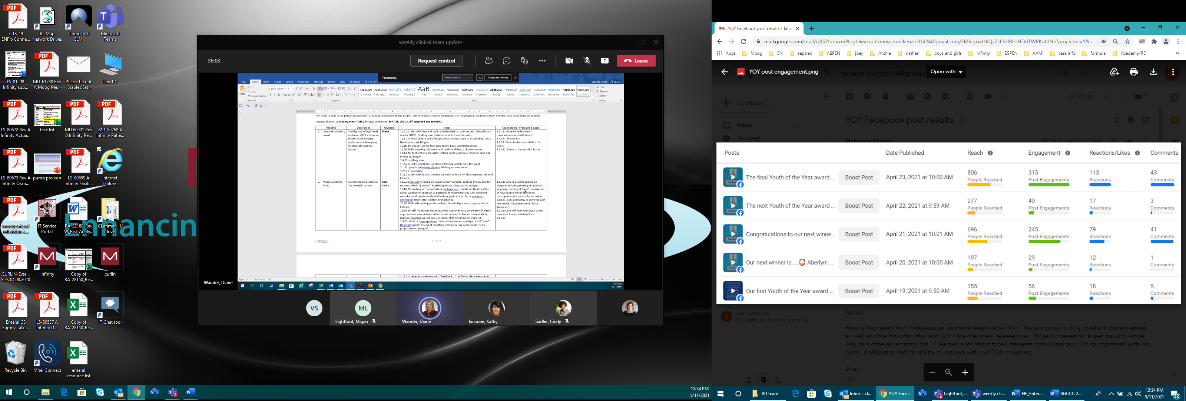

**Group discussion:**

* What went well
  + ~10x more views than what we did in the past
  + Videos are still accessible for continued reach
  + Marji did a great job, sharing article and getting exposure!
* Even better if
  + Chaffee Co times article did not turn out too well
  + **Next year have in person plus week before have the highlight videos!**
  + Spot to honor youth of the year at the club-salida has a spot-Marji will follow up with brain on this for this year kids

*1:45-2:00 (15 minutes)*

**Drive In Summer Kick-Off**

**Date: May 27th (Thursday last day of school)**

*Marketing event to showcase our summer program offering with hopes of growing*

*membership and knowledge of what the club offers during the summer*

|  |  |  |  |
| --- | --- | --- | --- |
| Groups | Program Development Team | Marketing Event Team | Day of Support |
| Responsibilities | * Movie preview-*filmed* * Confirm movie *Sing* | * Develop marketing plan-*see below* * Free ticket *done* | * Ticket Sales * Putting up BGC banner * Running Movie Preview * Welcome announcements |
| Who | Cara/ Brian | Marji  Mckenzie |  |

**Update:**

* Gates open at 7:30pm, movie ~8:50pm
* Marketing plan (Marji)
  + flyer (& where distributed)
  + 4 insertions placed of ad (2 each in MM and CCT)
  + Facebook postings
  + Website
  + Constant contact
  + Will send a second constant contact blast
  + Chamber newsletters (posted on both salida and BV)
  + press release
* Ask Schools if they will hand out flyer or add to their announcements
  + Who: Brain sharing with Jenn and Kiki
* Posters around town:
  + Brian will ask Brandon and Jenn
* Club summer program video
  + Filmed
  + Edit by Greg plan to have draft to Brian and I by Monday

**Day of support:**

* Laptops
  + Laptop #1 Cara
  + Laptop #2: Julie
  + Laptop #3: mckenzie (Brian to get from her)
* Ticket Sales (1-2 people)
  + Person #1-karen
  + Person #2-Duncan
  + Need to bring square like device-heart of gives to donate now
  + Brian to bring cash bag for change
  + Summer program flyers and Banner (print front and back salida and bv)
  + Cara email barb to get in at 7:15pm
  + Chamber billboard brian will reach out to see if they can add it if not will ask about gala event

*2:00-2:15 (15 minutes)*

**Sponsors Team Discussion**

**Update:**

* Review current sponsor status
* Need to schedule “sponsor commercial” filming for Peak sponsors
* What is going well? Any even better if?

|  |  |  |  |
| --- | --- | --- | --- |
| Who | 2019 | 2020 | 2021 |
| Buena Vista Veterinary Clinic, Greg & Dale Kettering | $2,500 | $3,000 | $6,000 |
| High Country Bank | $2,500 | $3,000 | $6,000 |
| BURM | $2,500 | $3,000 | $3,000 |
| Elevation Beer Company | $1,000 | $1,250 | $3,000 |
| Heart of the Rockies Regional Medical Center |  | $3,000 | $3,000 |
| Jenna L. Mazzucca, Esq., PC |  | $500 | $3,000 |
| Nestles waters "blue triton brands" | $1,000 | $3,000 | $3,000 |
| Republic National Distributing | $2,500 | $3,000 | $3,000 |
| Salida Pharmacy & Fountain |  |  | $1,250 |
| Brown Dog Coffee Company-BV | $250 |  | $500 |
| Mariposa Window & Door | $250 | $250 | $500 |
| Su Casa! Furniture & Sleep Shop | $500 | GC | $500 |
| Wag-N-Tails | $250 | $250 | $300 |
| The Beekeeper's Honey Boutique |  |  | $200 |
| Mt. Shavano Ski Rental Inc | $150 |  | $100 |
| **Total** |  |  | **$33,350** |

* September 1 deadline for Gala marketing benefits
* Julie will follow up community volunteer on dates needed
  + If not we need to circle back with realtors ourselves

**Need to email kiki the title and peak sponsor so it’s on the monitor**

*2:15-2:25 (10 minutes)*

**Ribbon Cutting event Julie**

Ribbon Cutting Event at Salida Club

* Date: June 12th
* Time: 10am and noon
* What to expect
  + Email constant contact invite list
  + 10 am ribbon cutting then 10:10-11 tours; 11 ribbon to teen or gym; noon next ribbon cutting followed by more tours
  + Snacks
  + We are announcing the capital campaign at this event

July 17th a more private ribbon cutting (invite only)

Need to add the sponosors to the slide show at the salida club

*2:25-2:40 (15 minutes)*

**Stewardship Event Team Discussion**

**Date: July 27th at Surf Hotel (Tuesday)**

*Invite only Thank you Event*

|  |  |  |  |
| --- | --- | --- | --- |
| Groups | Program Development Team | Invite List Team (top 80-100) | Day of Support |
| Responsibilities | * Create Content for the program | * Develop the invite list * Save the date * invite | * Event Set up * Event take down * Etc…..more to come |
| who | **Julie/Brian** | **Julie**  Brian  Duncan  Karen  **Subcommittee meeting every Tuesday** |  |

Event Logistics Lead: Jeanine

* Will follow up to get official contract confirmed
* Minimum is $50 per person (drinks/aps)

Subcommittee

* Invite list
* Save the date/invitation
* Program content

Ideas:

* Kids call to invite folks

*NO PLANS TO DISCUSS UNLESS THERE ARE UPDATES ON 5/11 RD CALL*

**Joint Event “Great Futures Gala: Let’s Get Back to the Future”**

**Date: September 28th at Mt Princeton (Tuesday)**

Theme: Futuristic (Think Space, Robots, Men in Black, Back to the future 2, Galaxy)

Event Logistics Lead: Jeanine

Needs/Next steps:

* Large auction items: need everyone to brainstorm
  + Julie: timeshare in palm springs or in Mexico
  + Karen: has Conrad Nelson artist for large auction item
* “active” entertainment ideas
  + Happy hour -live painter Joshua Been (tbd) then auction off painting of the view-Duncan will notify
  + Mentalist Sean Bott CONFIRMED
  + Auctioneer Jim Wilson CONFIRMED

|  |  |  |  |  |
| --- | --- | --- | --- | --- |
| Groups | Program Development Team | Marketing Event Team | Ticket Sales | Day of Support |
| Responsibilities | * Create Content for the program | * Develop marketing plan * Create Ticket | * Develop plan for ticket sales | * Event Set up * Event check in * Event take down * Etc…..more to come |
| Who | TBD | | | |

**Tickets: then allow option for additional donation**